# How to set JAVA_HOME

Tested with:

1. Windows 10
2. JDK 1.8

## 1. Advanced System Settings

Type advanced system settings in the search box (beside the Windows start button), clicks View advanced system settings.

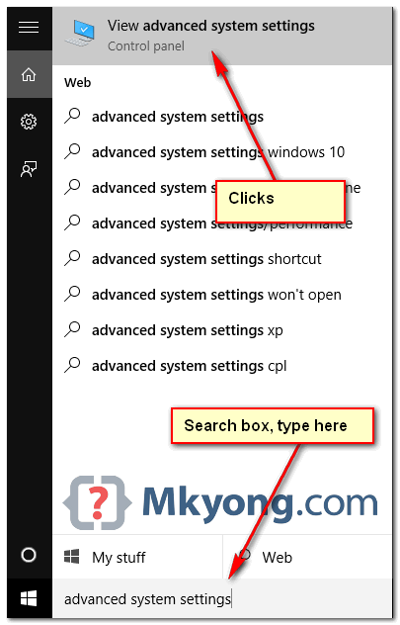

## 2. Environment Variables

Select Advance tab, clicks Environment Variables

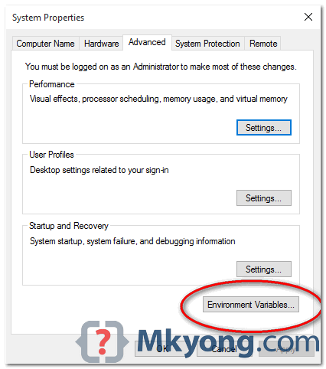

## 3. Add JAVA_HOME

In System variables, clicks New... button to add a new JAVA_HOME variable and point it to the JDK installed folder.

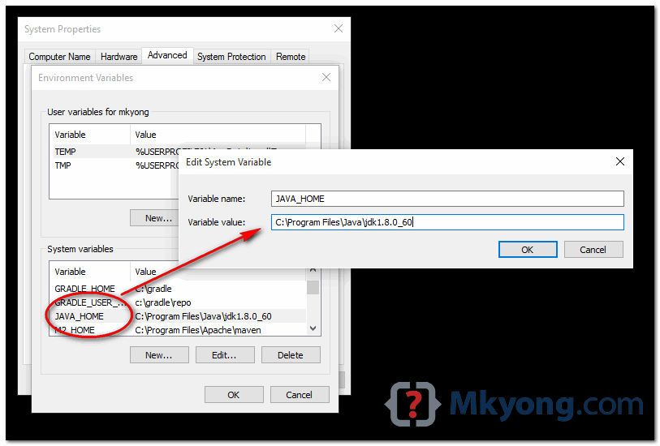

**Note**  
Don’t include the \bin folder, just the JDK path. For example

1. **Correct – C:\Program Files\Java\jdk1.8.0_60**
2. Wrong – C:\Program Files\Java\jdk1.8.0_60\bin

## 4. Update PATH

In System variables, find PATH, clicks edit... button :

4.1 In old version of Windows, it will prompt you below dialog box to edit the values directly, append this %JAVA_HOME%\bin; to the end of the line.

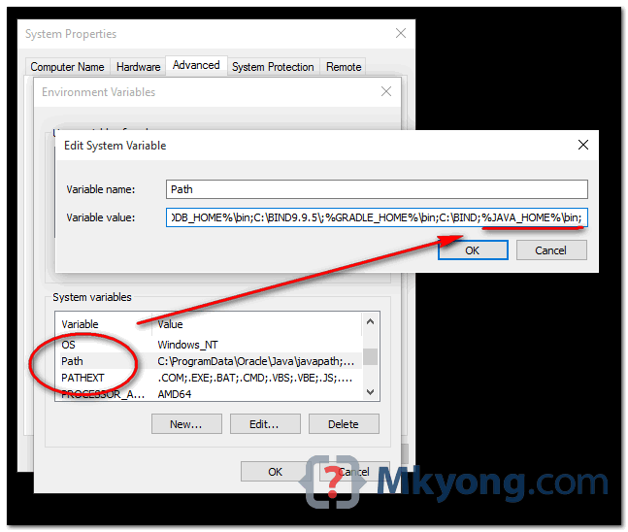

4.2 In latest Windows 10, it will prompt you below dialog box, clicks on New button, and add this %JAVA_HOME%\bin

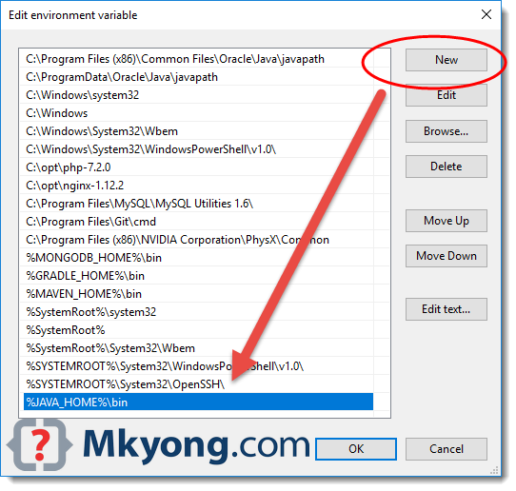

**Note**  
Puts the %JAVA_HOME%\bin in PATH make all the Java’s commands (java, javac, jstack and etc) are accessible from everywhere.

## 5. Test

Open a command prompt, type :

C:\Users\mkyong>java -version

java version "1.8.0_60"

Java(TM) SE Runtime Environment (build 1.8.0_60-b27)

Java HotSpot(TM) 64-Bit Server VM (build 25.60-b23, mixed mode)

C:\Users\mkyong>javac -version

javac 1.8.0_60

C:\Users\mkyong>echo %JAVA_HOME%

C:\Program Files\Java\jdk1.8.0_60

**How to install Maven**

To install [Apache Maven](http://maven.apache.org/) on Windows, you just need to download the Maven’s zip file, unzip it to a folder, and configure the Windows environment variables.

Tested with :

1. JDK 10
2. Maven 3.6
3. Windows 10

**Note**

1. Maven 3.3+ requires JDK 1.7+
2. Maven 3.2 requires JDK 1.6+
3. Maven 3.0/3.1 requires JDK 1.5+

## 1. JDK and JAVA_HOME

Make sure JDK is installed, and JAVA_HOME environment variable is configured.

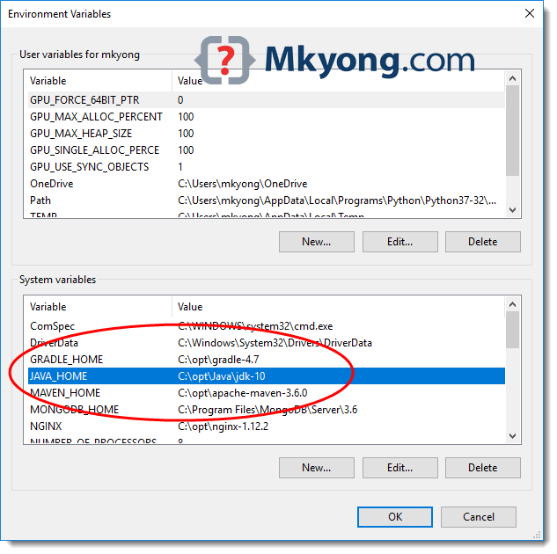

## 2. Download Apache Maven

2.1 Visit [Maven official website](http://maven.apache.org/download.cgi), download the Maven zip file, for example : apache-maven-3.6.0-bin.zip.

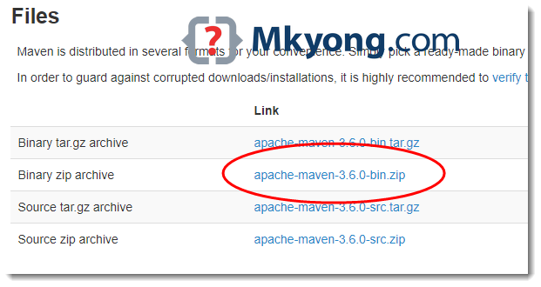

2.2 Unzip it to a folder. In this article, we are using c:\opt\apache-maven-3.6.0

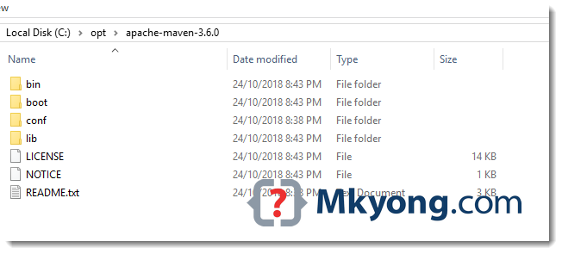

**Note**  
That’s all, just download and unzip, installation is NOT required.

## 3. Add MAVEN_HOME system variable

Add a MAVEN_HOME system variables, and point it to the Maven folder.

3.1 Press Windows key, type adva and clicks on the View advanced system settings

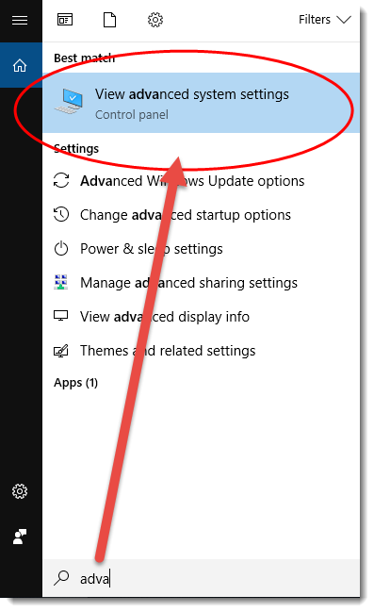

3.2 In System Properties dialog, select Advanced tab and clicks on the Environment Variables... button.

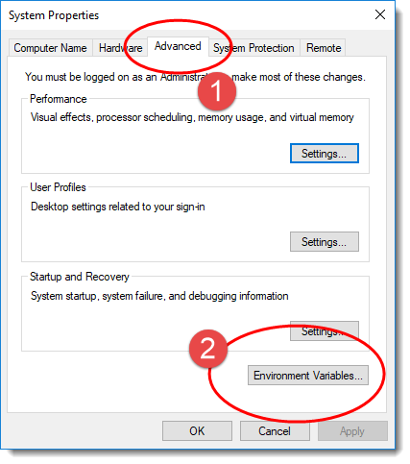

3.3 In “Environment variables” dialog, System variables, Clicks on the New... button and add a MAVEN_HOME variable and point it to c:\opt\apache-maven-3.6.0

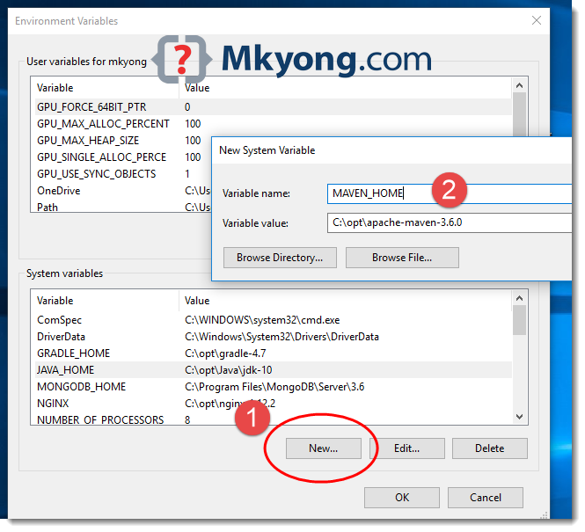

## 4. Add %MAVEN_HOME%\bin To PATH

In system variables, find PATH, clicks on the Edit... button. In “Edit environment variable” dialog, clicks on the New button and add this %MAVEN_HOME%\bin

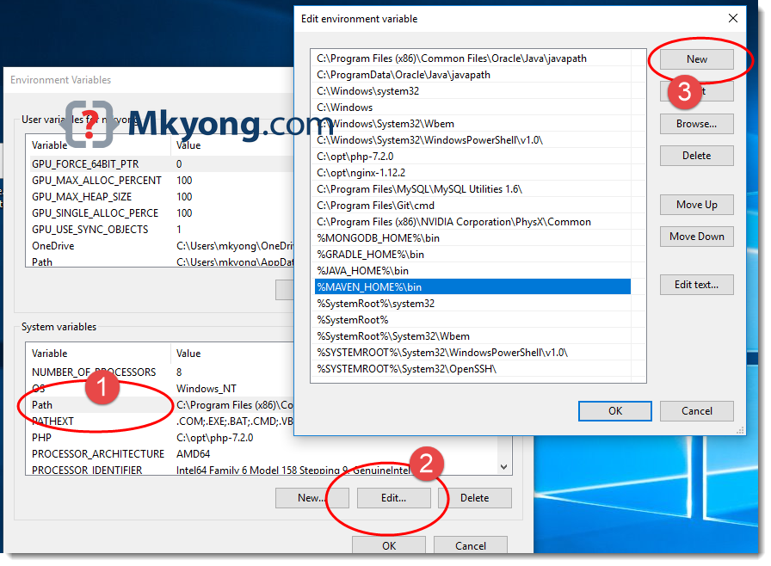

## 5. Verification

Done, start a new command prompt, type mvn –version :

C:\Users\mkyong>mvn -version

Apache Maven 3.6.0 (97c98ec64a1fdfee7767ce5ffb20918da4f719f3; 2018-10-25T02:41:47+08:00)

Maven home: C:\opt\apache-maven-3.6.0\bin\..

Java version: 10.0.1, vendor: Oracle Corporation, runtime: C:\opt\Java\jdk-10

Default locale: en_MY, platform encoding: Cp1252

OS name: "windows 10", version: "10.0", arch: "amd64", family: "windows"

C:\Users\mkyong>echo %MAVEN_HOME%

C:\opt\apache-maven-3.6.0

## 6. FAQs

6.1 ‘mvn’ is not recognized as an internal or external command?

> mvn -version

'mvn' is not recognized as an internal or external command,

operable program or batch file.

Copy

**Answer:** Refer to Step 4, make sure the %MAVEN_HOME%\bin is added to the PATH system variable.

6.2 The JAVA_HOME environment variable is not defined correctly

> mvn -version

The JAVA_HOME environment variable is not defined correctly

This environment variable is needed to run this program

NB: JAVA_HOME should point to a JDK not a JRE

Copy

**Answer:** Refer to Step 2, make sure JDK is installed and the JAVA_HOME system variable is configured.

**How to set POM.xml**

**Copy and paste following data in to Pom.xml file**

<build>

<plugins>

<!-- Compiler plug-in -->

<plugin>

<groupId>org.apache.maven.plugins</groupId>

<artifactId>maven-compiler-plugin</artifactId>

<version>3.5.1</version>

<configuration>

<source>${jdk.level}</source>

<target>${jdk.level}</target>

</configuration>

</plugin>

<!-- Added Surefire Plugin configuration to execute tests -->

<plugin>

<groupId>org.apache.maven.plugins</groupId>

<artifactId>maven-surefire-plugin</artifactId>

<version>2.19.1</version>

<configuration>

<testFailureIgnore>true</testFailureIgnore>

<argLine>

-javaagent:"${settings.localRepository}/org/aspectj/aspectjweaver/${aspectj.version}/aspectjweaver-${aspectj.version}.jar"

</argLine>

<suiteXmlFiles>

<suiteXmlFile>testng.xml</suiteXmlFile>

</suiteXmlFiles>

</configuration>

<dependencies>

<dependency>

<groupId>org.aspectj</groupId>

<artifactId>aspectjweaver</artifactId>

<version>${aspectj.version}</version>

</dependency>

</dependencies>

</plugin>

</plugins>

</build>

<dependencies>

<!-- Selenium -->

<dependency>

<groupId>org.seleniumhq.selenium</groupId>

<artifactId>selenium-java</artifactId>

<version>3.14.0</version>

</dependency>

<!-- TestNG -->

<!-- https://mvnrepository.com/artifact/org.testng/testng -->

<dependency>

<groupId>org.testng</groupId>

<artifactId>testng</artifactId>

<version>6.14.2</version>

</dependency>

<!-- https://mvnrepository.com/artifact/com.testautomationguru.pdfutil/pdf-util -->

<dependency>

<groupId>com.testautomationguru.pdfutil</groupId>

<artifactId>pdf-util</artifactId>

<version>0.0.3</version>

</dependency>

<dependency>

<groupId>org.apache.poi</groupId>

<artifactId>poi</artifactId>

<version>3.13</version>

</dependency>

<dependency>

<groupId>org.apache.poi</groupId>

<artifactId>poi-ooxml</artifactId>

<version>3.13</version>

</dependency>

<dependency>

<groupId>org.apache.poi</groupId>

<artifactId>poi-ooxml-schemas</artifactId>

<version>3.9</version>

</dependency>

<dependency>

<groupId>org.apache.poi</groupId>

<artifactId>poi-scratchpad</artifactId>

<version>3.9</version>

</dependency>

<dependency>

<groupId>org.apache.poi</groupId>

<artifactId>ooxml-schemas</artifactId>

<version>1.1</version>

</dependency>

<dependency>

<groupId>org.apache.poi</groupId>

<artifactId>openxml4j</artifactId>

<version>1.0-beta</version>

</dependency>

<!-- https://mvnrepository.com/artifact/io.qameta.allure/allure-testng -->

<dependency>

<groupId>io.qameta.allure</groupId>

<artifactId>allure-testng</artifactId>

<version>2.10.0</version>

</dependency>

<!-- https://mvnrepository.com/artifact/org.apache.commons/commons-csv -->

<dependency>

<groupId>org.apache.commons</groupId>

<artifactId>commons-csv</artifactId>

<version>1.4</version>

</dependency>

</dependencies>

<reporting>

<excludeDefaults>true</excludeDefaults>

<plugins>

<plugin>

<groupId>io.qameta.allure</groupId>

<artifactId>allure-maven</artifactId>

<version>2.10.0</version>

</plugin>

</plugins>

</reporting>